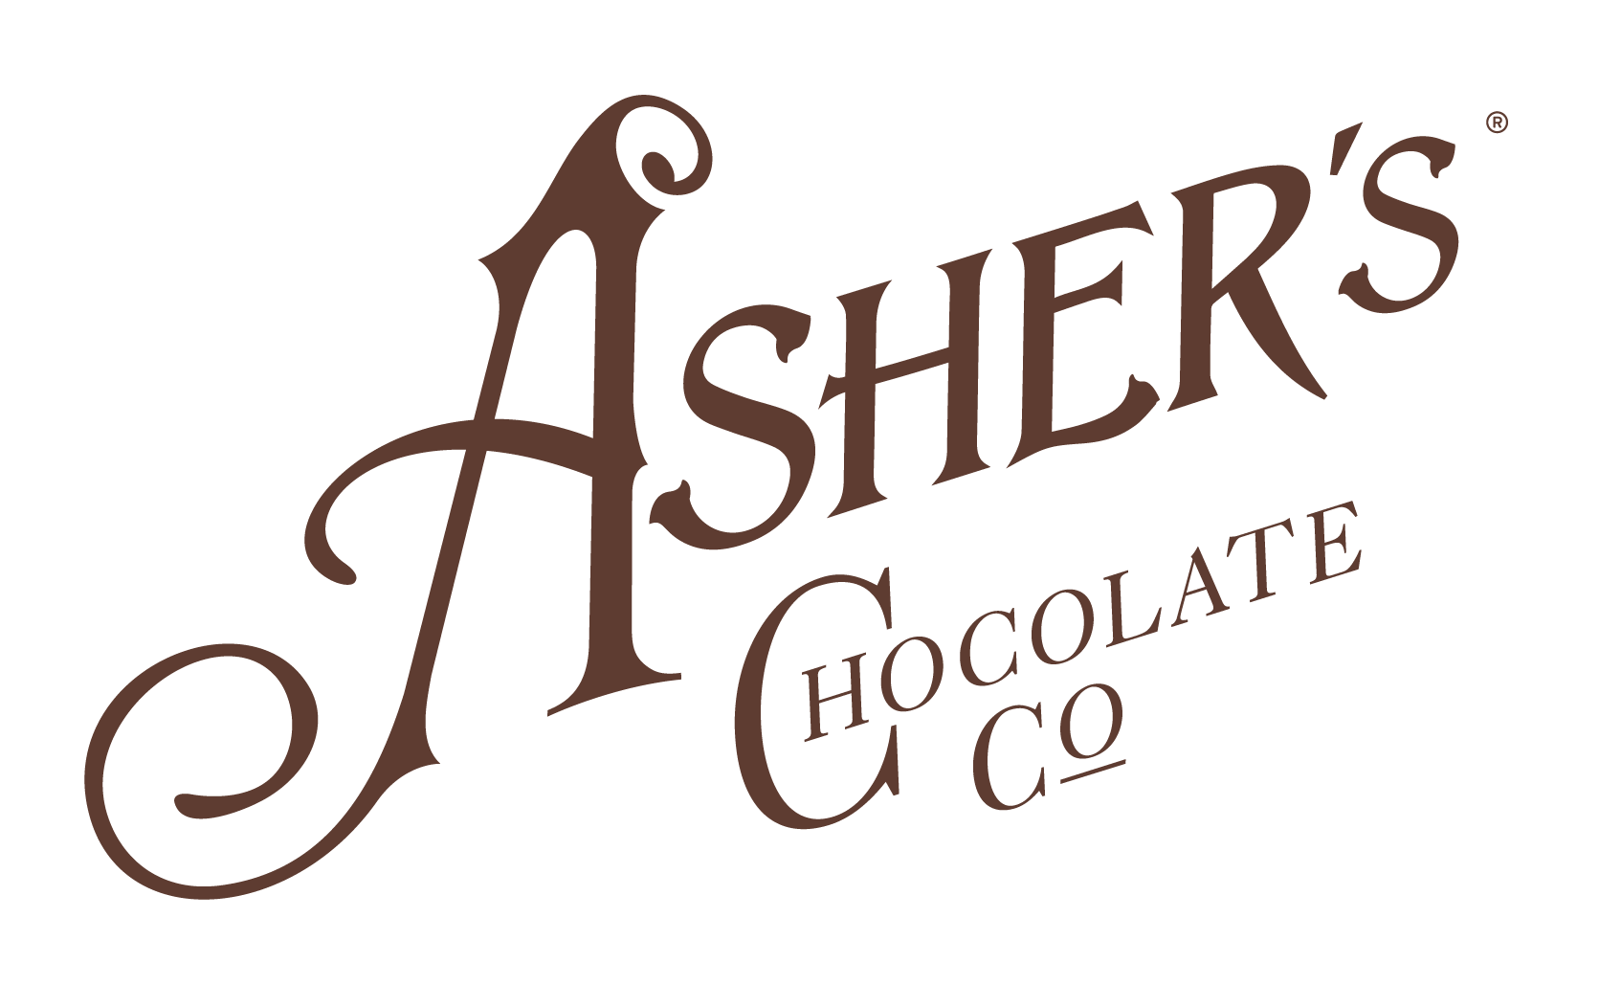

DONATION/SPONSORSHIP REQUEST FORM

TODAY’S DATE

NON-PROFIT NAME

501 C3 NUMBER

ORGANIZATION ADDRESS

YOUR NAME

YOUR EMAIL

YOUR PHONE NUMBER

BRIEFLY DESCRIBE YOUR ORGANIZATION

HAVE YOU RECEIVED A DONATION/SPONSORSHIP FROM ASHER’S BEFORE?

EVENT/REQUESTED FULFILLMENT DATE

BRIEFLY DESCRIBE YOUR EVENT OR REASON FOR DONATION REQUEST

WHAT ARE YOU REQUESTING? | PRODUCT/  CANDY | GIFT  BASKET | GIFT CARD  AMOUNT: | MONETARY DONATION/  SPONSORSHIP | OTHER:
WHAT OTHER COMPANIES WILL BE PROVIDING DONATIONS/SPONSORSHIPS?

HOW WILL YOU TELL SUPPORTERS ABOUT OUR DONATION?
(E.G. ADVERTISEMENT, LOGO ON SIGNAGE, ETC.)

* ALL DONATIONS (PRODUCT, CANDY, GIFT BASKETS, GIFTS CARDS) ARE TO BE PICKED UP AT EITHER OUR SOUDERTON OR LEWISTOWN RETAIL STORES. UNFORTUNATELY, THE ONLY DONATION/SPONSORSHIP TYPE WE CAN MAIL/SHIP IS A MONETARY DONATION IN THE FORM OF A CHECK.

